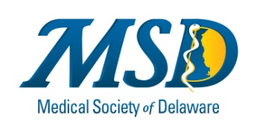

EXECUTIVE BOARD/COUNCIL/MSD HOLDING COMPANY

2021 Meeting Schedule

DATE MEETING LOCATION TIME

(AMA State Advocacy Summit virtual
Jan 6-8)
January 14, 2021 Executive Board/ TBD 6:00 pm
Holding Company

February 11, 2021 Executive Board TBD 6:00 pm
(AMA NAC –Feb 23-24) virtual

March 11, 2021 Executive Board TBD 6:00 pm

April 8, 2021 Interim Council Meeting TBD 6:00 pm

May 13, 2021 Executive Board TBD 6:00 pm

June 10, 2021 Executive Board TBD 6:00 pm
(AMA Annual Mtg June 12-16)

July 8, 2021 Executive Board/ TBD 6:00 pm
Holding Company

August NO MEETING

September 9, 2021 Executive Board TBD 6:00 pm

October 21, 2021** Executive Board TBD 6:00 pm

(AMA Interim Mtg Nov. 13-16)
November 20, 2021 Annual Meeting/Council TBD 7:00 am -
Annual Meeting/Holding Co. 12:30pm

December 9, 2021 Executive Board TBD 6:00 pm

*Executive Board meetings held in Dover will assume an in-person participation only. Executive Board Meetings held at MSD in Newark are formatted with televideo conferencing option for those in Kent and Sussex Counties

